(1) List the major modules of your project and the connection between them.

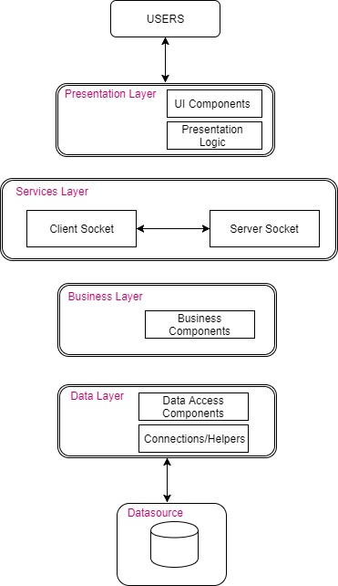

(2) Use Class Diagrams to show the main classes and the relationships between them. There should be two class diagrams: one for client side and the other for server side.

**Client Class Diagram**

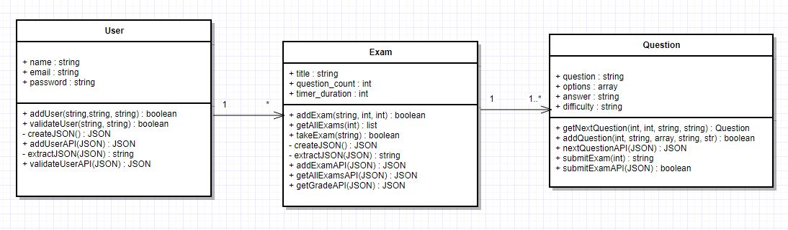

**Server Class Diagram**

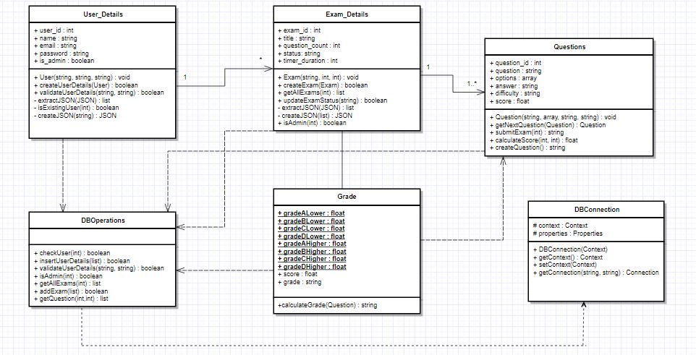

(3) Use Sequence Diagrams to show the workflow for your project. If you think that other UML diagrams (such as activity diagrams or use case diagrams) are more proper for your project, please feel free to apply these UML diagrams.

**User Registration:** User registering for Exam Portal

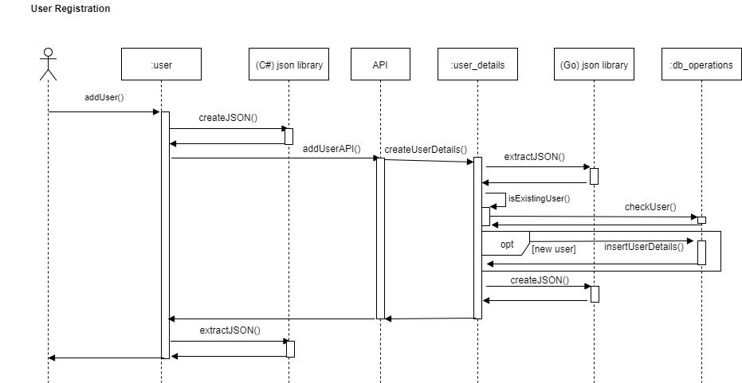

**User Login :** User or admin logins

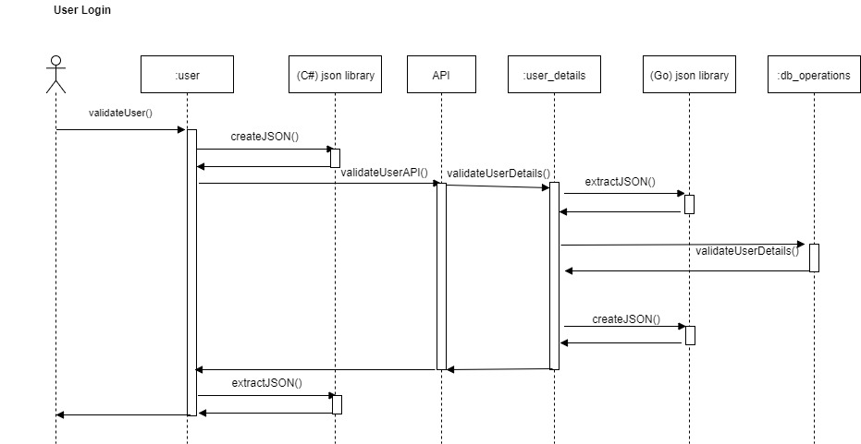

**User Home Page:** User/Admin views the exams taken/added

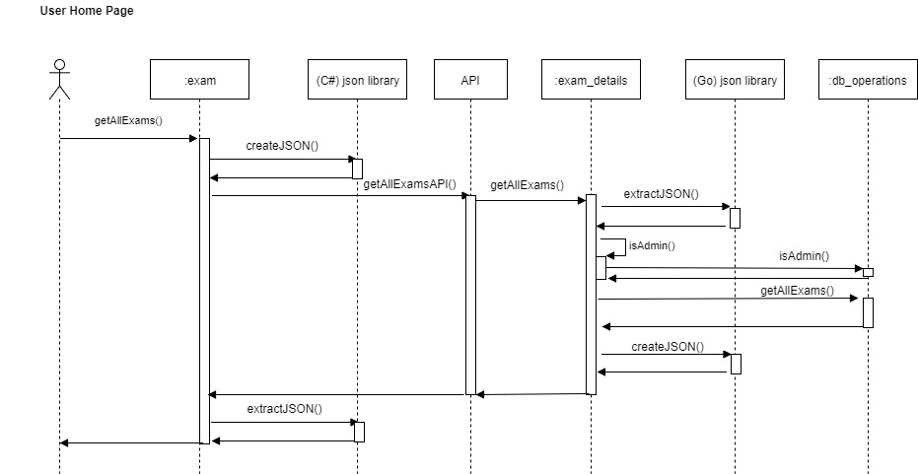

**Take Exam :** User registering and taking an exam

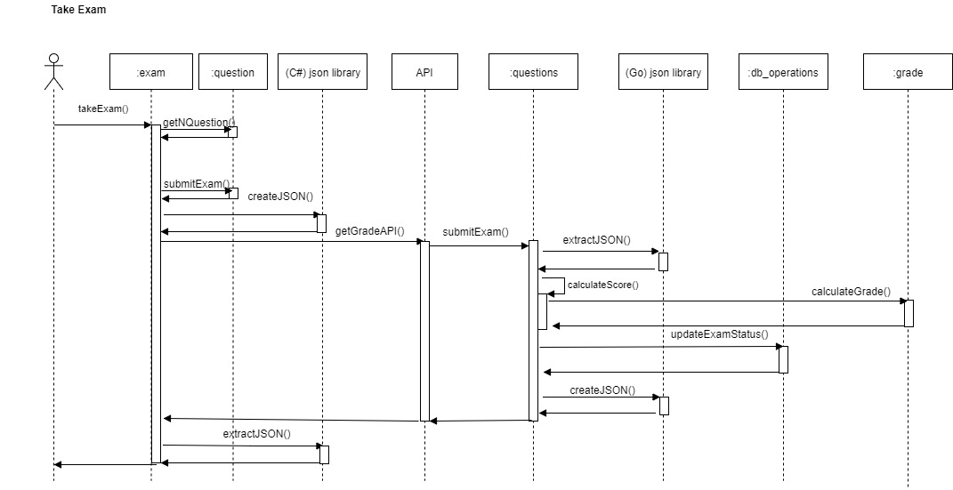

**Add Exam:** Admin adding an exam

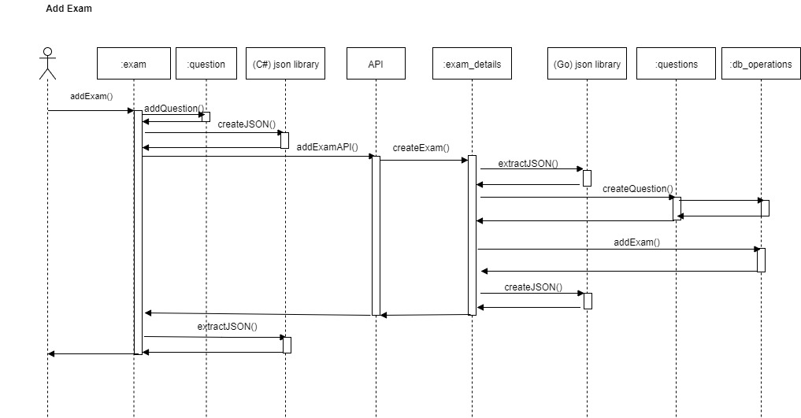

**Get Next Question:** User getting next question based on the previous response

